**Ideation Phase**

**Brainstorm & Idea Prioritization Template**

|  |  |
| --- | --- |
| Date | 26.06.2025 |
| Team ID | SWUID20250170870 |
| Project Name | Freelancing Application Mern |
| Maximum Marks | 4 Marks |

**Brainstorm & Idea Prioritization Template:**

Brainstorming provides a free and open environment that encourages everyone within a team to participate in the creative thinking process that leads to problem solving. Prioritizing volume over value, out-of-the-box ideas are welcome and built upon, and all participants are encouraged to collaborate, helping each other develop a rich amount of creative solutions.

Use this template in your own brainstorming sessions so your team can unleash their imagination and start shaping concepts even if you're not sitting in the same room.

Reference: <https://www.mural.co/templates/brainstorm-and-idea-prioritization>

**Step-1: Team Gathering, Collaboration and Select the Problem Statement**

**Collaboration :** In the collaboration phase of our freelancing application (MERN stack) project, the team came together to collectively understand the purpose of the platform and identify the key problems faced by freelancers, clients, and platform admins. Each member contributed insights based on real-world challenges—such as the lack of secure payment systems for freelancers, difficulties clients experience in finding reliable talent, and the need for effective admin tools to maintain platform integrity. This shared understanding formed the foundation for our brainstorming sessions, where we openly listed and discussed a wide range of potential features and solutions. Ideas were then grouped into categories like authentication, project management, communication, and feedback systems. Finally, through team discussions and evaluation, we prioritized each idea by importance and feasibility, creating a clear development roadmap. This collaborative effort ensured that all perspectives were considered and that our priorities were aligned toward building a secure, user-friendly, and scalable freelancing platform using MongoDB, Express.js, React.js, and Node.js.

**Problem Statement :** Creating an efficient and secure freelancing platform that allows clients to post projects, freelancers to bid and collaborate, and admins to ensure platform integrity fostering a reliable digital work environment.

**Why This Problem?**

* Freelancers struggle to find legitimate platforms with secure payments and fair treatment.
* Clients need a trustworthy space to find skilled freelancers.
* Admins must maintain platform health and ensure data security

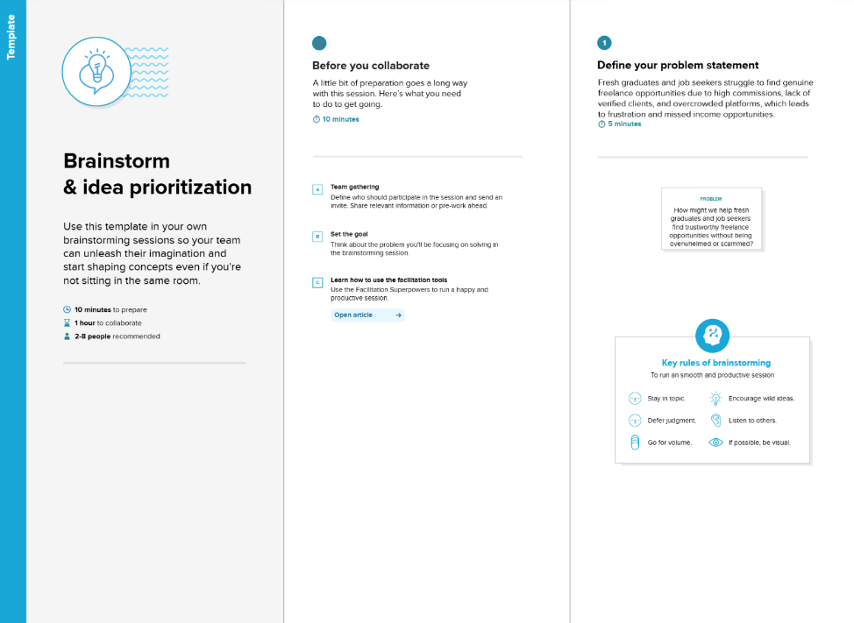

**Step-2: Brainstorm, Idea Listing and Grouping :**

In this step, the team organized a brainstorming session to generate as many ideas as possible for the freelancing platform without filtering or judging them too early. The goal was to think broadly about all the features, tools, and functions that could solve the problems identified in Step 1—such as making the platform secure, user-friendly, and reliable for freelancers, clients, and admins.

Everyone contributed ideas based on their research and experience. These ideas included secure authentication methods (like JWT and bcrypt), project posting and bidding systems, freelancer portfolios, role-based dashboards, real-time chat and notifications, admin moderation tools, payment integrations, and feedback or rating mechanisms.

After listing all ideas, the team grouped similar or related features into logical categories to make them easier to understand and manage. For example, all security-related ideas were grouped under Authentication & Security, communication-related ideas under Messaging & Notifications, and admin functions under Moderation & Control.

This grouping helped the team see the big picture of the platform’s scope and ensured no important area was missed. It also made it simpler to move to the next step of deciding which features to prioritize first.

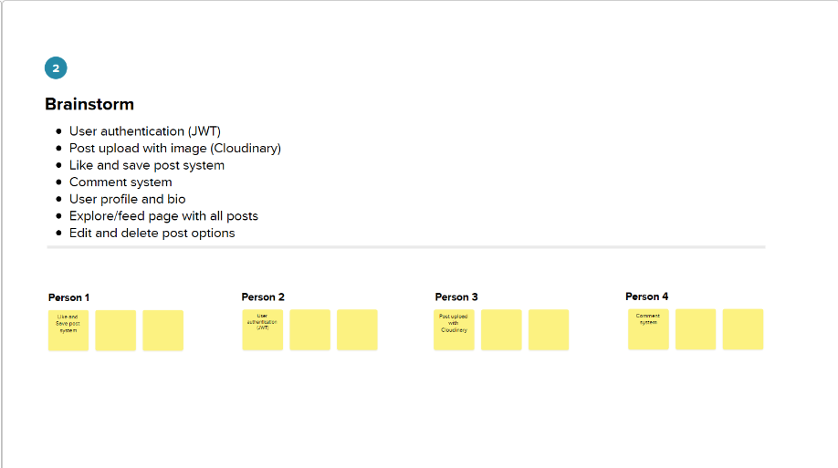

**Step-2: Group Idea (Solo Adaptation) :**

|  |  |
| --- | --- |
| **Category** | **Ideas** |
| Authentication & Security | Secure Login, JWT Tokens, bcrypt |
| |  | | --- | | Project Management | | Proposal Submission, Project Posting |
| User Experience | Role-Based Dashboards, Notifications |
| Communication | Real-time Chat, Video Calls |
| Moderation | |  | | --- | | Admin Tools | |
| Trust & Feedback | Reviews, Ratings |
| Performance | |  | | --- | | Global State with React Context | |

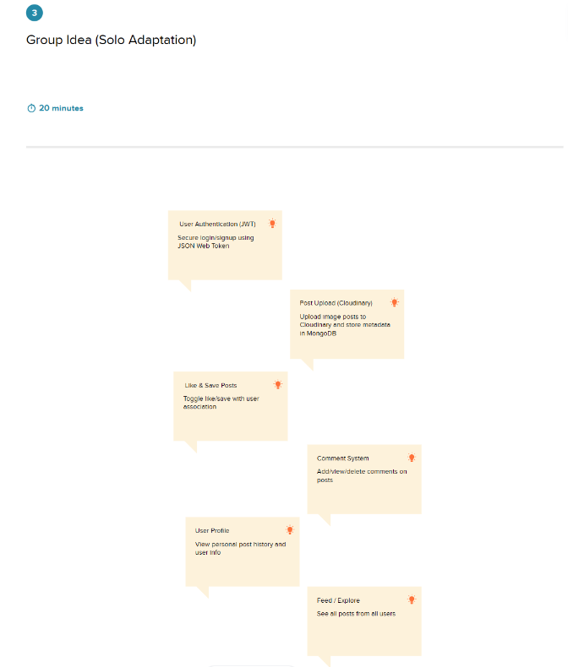

**Step-3: Idea Prioritization :**

| Priority | Feature / Idea | Justification / Reason |
| --- | --- | --- |
| High | Secure Authentication (JWT + bcrypt) | Essential to protect user accounts and data; required for secure access. |
| High | Project Posting and Proposal Submission | Core functionality for connecting clients and freelancers. |
| High | Role-Based Dashboards | Improves user experience by tailoring views for clients, freelancers, admins. |
| Medium | Admin Moderation Tools | Important for managing users and maintaining platform integrity. |
| Medium | Feedback and Review System | Builds trust between users and improves transparency. |
| Medium | Real-Time Notifications | Keeps users informed and engaged with updates. |
| Low | Video Call Feature | Enhances communication but not critical for initial launch. |
| Low | Global State Management with React Context | Optimizes performance and state handling but can be added later. |

